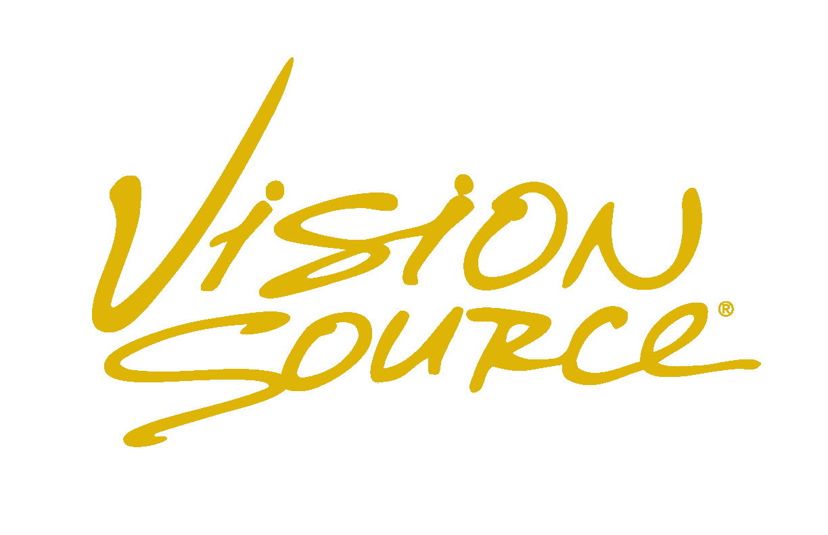
Optos Retinal Imaging and Optovue CT Scan
Mount Vernon Vision Source is pleased to provide our valued patients with advanced technology called Optos and Optovue CT scan. Optos is a high resolution screening photograph of your retina which will help us document, review, and compare your retina over time. Optovue CT scan uses specifically focused light to do a “cat” scan of your retina. Our doctors consider this an important part of every full eye health exam and highly recommend it for all patients.
YES, I choose to have the Optos retinal imaging and Optovue CT scan of the retina for an additional fee of $45 (children 17 and under $25) due at the time of service. If our doctors determine that additional comprehensive testing is medically necessary, they will discuss that fully with you. These additional charges may be billed to a current accepted medical insurance as discussed below.
**Please note that we will no longer be able to bill insurance for the screening. If you would like us to bill your insurance due to a medical condition, we will then conduct a full high-resolution fundus photo and/or CT scan that may be subject to your annual deductible, co-pays and/or coinsurance. Current high resolution photos are $110 and full CT scans are $125.
NO, I do not wish to have the Optos retinal imaging and Optovue CT scan. At this time, I am declining the doctor’s recommendations to obtain a comprehensive image of my retina with the full understanding that I will still have a thorough eye examination with slit lamp observation and possible dilation.
Account Guarantor Signature ________________________________ Date ___________________________
Financial Policy
As a service to me, Mount Vernon Vision Source may request payment from my insurance company made on my behalf or on the behalf of my dependant (s). I understand and acknowledge that Mount Vernon Vision Source is not responsible for any incorrect or incomplete insurance information. Benefits quoted to me by Mount Vernon Vision Source or my insurance company is not a guarantee of payment. If my insurer denies coverage or Mount Vernon Vision Source does not receive payment within 45 days from filing the claim, the amount may then become due and payable by me.
I authorize payment to be made directly to Tod W. Jones, DBA Mount Vernon Vision Source, by my insurance company. I understand that I am fully responsible for all services rendered and that payment of co-pay’s, items not payable by insurance, and any co-insurance is due at the time of service. Accepted forms of personal payment are cash, check, Visa, MasterCard, or American Express. There will be a $35 charge assessed on all returned checks. A service charge of 1.5% per month on all balances of sixty days or greater, with a minimum $5.00 late charge, will be assessed on your account.
Account Guarantor Signature ________________________________ Date ___________________________

Notice of Privacy Practices Good Faith Acknowledgement
By federal law, Mount Vernon Vision Source abides by the terms of HIPAA. By signing below, I acknowledge that a copy of Mount Vernon Vision Source’s Notice of Privacy Practices is available to me at any time and will be provided if I so request.

Account Guarantor Signature ________________________________ Date ___________________________

